# MSE Documentation

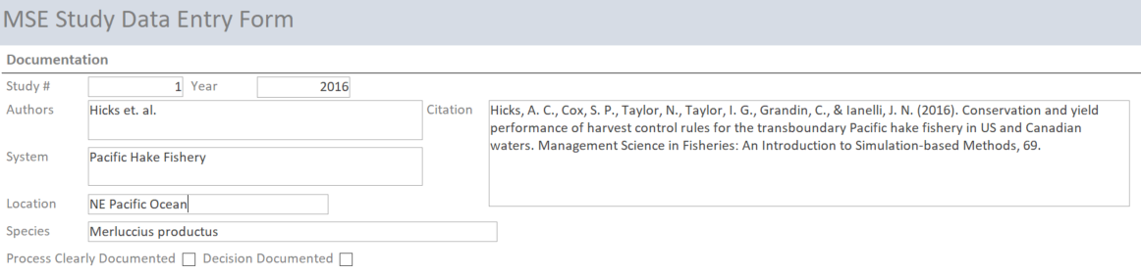

Study #: a unique identifier for each study

Year: Year of publication

Authors: Authors of the documentation

System: Text description of the study setting

Citation: Full citation of the MSE documentation

Location: The water body the MSE studied

Species: The species the MSE studied

Process Clearly Documented: Was the decision process, i.e., the details of the steps taken in the MSE, clearly documented?

Decision Documented: Was an alternative selected for implementation by the management body and was the decision documented?

# MSE Participants



Leader: Who triggered the MSE process and moved it forward?

* Government Agency, Management Organization, Fishery Stakeholders, Independent Stakeholders, Scientific Organization

Participants: Which categories of participants were included in the decision process?

* Facilitators, Decision Makers, Stakeholders, Experts, Decision Analysts

Roles Cleary Specified: Were the tasks for the participants identified?

Open Meetings: Were stakeholders or the public invited to attend decision process meetings?

# MSE Problem Definition

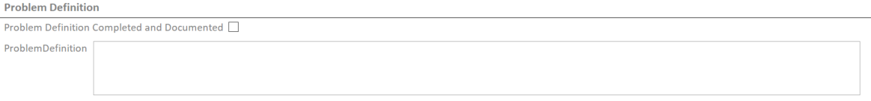

Problem Definition Completed and Documented: Was a problem definition step completed and documented as part of the MSE process?

Problem Definition: My summary of the problem the MSE is intended to address

# MSE Objectives

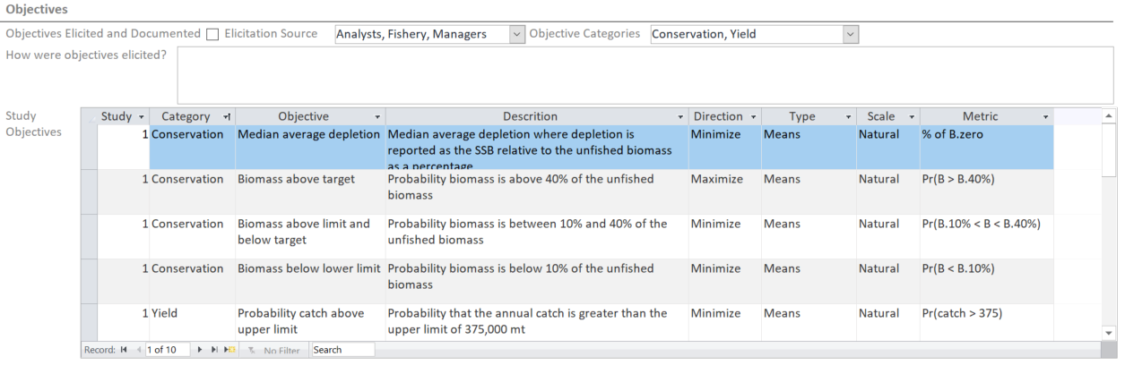

Objectives Elicited and Documented: Was the objective identification process documented?

Elicitation Source: Who provided objectives for the MSE to evaluate?

* Government, Management, Fishery, Public, MSE analysts, Experts, Unknown

Objective Categories: Which categories of objectives were included in the decision process?

* Conservation, Yield, Economic, Social

How were objectives elicited: Text description of the process that was used to produce the objectives and performance measures for the MSE?

Study Objectives: Details about the individual objectives evaluated

Study: Identifier to link the objective information to the study

Category: What category is the objective related to

Objective: Name of the objective

Description: Longer text description of the objective and the concern it captures

Direction: Desired state of the objective

Type: Objective type (Fundamental, Means, Strategic, Process)

Scale: Measurable unit scale (Natural, Proxy, Constructed)

Metric: Measurable unit (aka performance measure, criteria, etc.) description

# MSE Alternatives

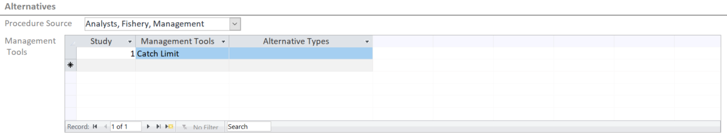

Procedure Source: Who provided the management procedures (aka alternatives) to be evaluated in the MSE?

* Government, Management, Fishery, Public, MSE analysts, Experts, Unknown

Management Tools: Details about the individual procedures evaluated

Study: Identifier to link the objective information to the study

Management Tools: What category of management tools were evaluated?

(Catch Limit, Effort Limit, Size Limit, Access Control, Share Allocation, Closures)

Alternative Types: Brief text description of the alternatives evaluated

# MSE Consequences and Tradeoffs

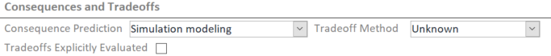

Consequence Prediction: What method was used to predict consequences?

* Simulation Modeling, Expert Elicitation

Tradeoff Method: What method was used to evaluate tradeoffs between objectives in the consequence evaluation?

* MCDA, Visualization, Negotiation, Mental Analysis, Unknown

Tradeoffs Explicitly Evaluated: Were tradeoffs between objectives accounted for in the MSE and the presentation of results?

# Notes and Comments



Additional information about the MSE that was not captured in the review questions.